Identify your Group Number: Name of Student:
Introduce yourself to your mates. List the full names of the members in your group, including the middle name. Starting with the first letter in the name list your mates in alphabetical order.
Example:(1) Anne Mary Bullock (2) Bradley Charles Cooper (3) Michael Jeffery Jordon, junior

Below is an excerpt from the book, Cyrus West Field, Big Dreams:

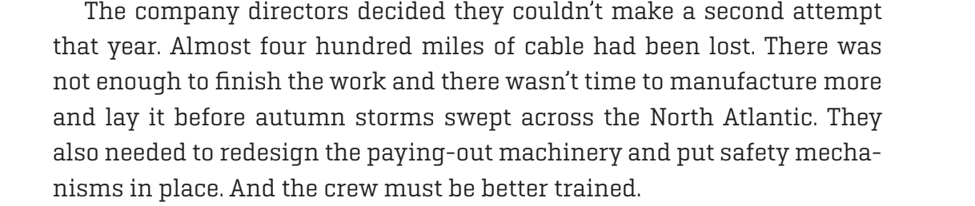
From the presentation there were a number of problems the project encountered on the journey across the ocean. As a group, choose one of three requirements from the reading that the Directors from Atlantic Cable Company needed resolved prior to a second attempt.
Describe the problem by writing a problem statement. Your problem statement must answer three questions:
  - What is the problem or need?
  - Who has the problem or need?
  - Why is it important to solve?
The statement should address which or how will the independent variable affect the dependent variable. Below are a few formats for writing a problem statement in which it uses the answers to the questions and follows these guidelines:
- Who need(s) what because why.
  - _____ need(s) _________ because ________.
  - Example: In order to provide excellent patient care at a minimal cost. Middletown Hospital needs diagnostic procedures that are safe, effective and accurate that are not overly painful to the patient.
- Which or How will the independent variable affect the dependent variable.
  - How will _________ affect ___________? OR Which __________ will __________?
  - Examples of problem statements:
- How will the height of the ramp affect the distance the car will travel?
- Which amount of salt dissolved will freeze in the shortest period of time?
Problem Statement:

Do Background Research:
- Most teachers will require you to find at least three sources of information.
- How to find information:
  - Find and read the general information contained in an encyclopedia, dictionary, or textbook for each of your keywords.
  - Use the bibliographies and sources in everything you read to find additional sources of information.
  - Search periodical indexes at your local library.
  - Search the Internet to get information from an organization, society or online database.
  - Broaden your search by adding words to your search phrases in search engines. Narrow your search by subtracting words from or simplifying your search phrases.
- When you find information, evaluate if it is good information:
Good References | Bad References
Come from a credible source | Come from a source with poor credibility
Not too old | Out of date
Not biased | Not objective and fair, biased towards one point of view
Free of errors | Prone to errors
Properly cite the original source of all information | Do not cite where the information came from
Easy for other people to find or obtain | Difficult for others to obtain
Do some searching on your own Problem Statement. List one possible Good Resource that you found. You will need to cite your website sources in the proper American Psychological Association (APA) format. APA is used for technical and scientific works. Click on this link to learn how to properly cite website sources in the APA format:
Cite one good resource in APA format. Include the type of website source by clicking the appropriate box below.

Format
Reference entry
In-Text Citation
You are citing an (a):
❑ Entire Website
❑ Online article
❑ Website with No authors
❑ Website with No date
❑ Social Media

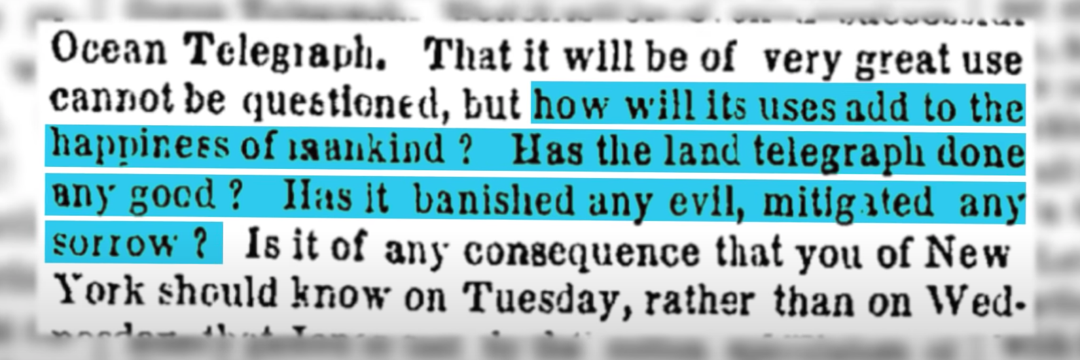
The commentator in the Bloomberg Uptake Video made the connection that the philosophical debate “will instant access to information make people happier or better off” not only occurred in the 1850s from the implementation of the Atlantic Cable but continues today with smartphones and other digital devices. As a group discuss if you agree or disagree with this statement then generate a supportive paragraph to support your claim. Below is a refresher on the requirements in a supportive paragraph.

How do you write a supportive paragraph?
Begin each supporting paragraph with a topic sentence. This statement reinforces your point for the reader. Everything in the paragraph should support the point you establish in the initial sentence. Use specific facts from your research and specific examples to enhance and clarify the point you are making.
Supporting Paragraph:

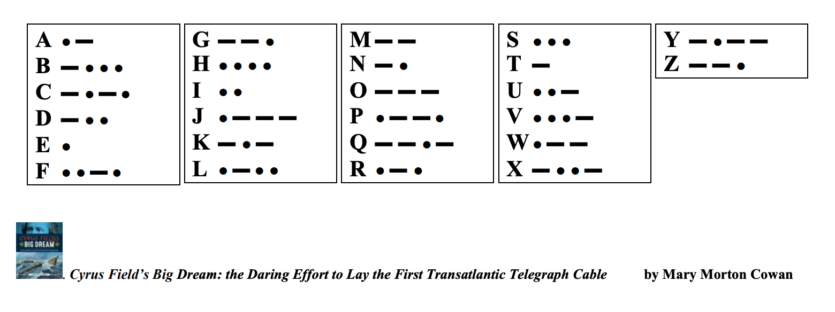
The electrical telegraph used Morse Code, a message system, in which electrical impulses were sent by wires then translated into letters then into words. Below, write your own name using Morse Code.

Collaboration Session Reflection:

Collaboration is the ability to work with others to meet specific expectations. Being able to communicate effectively with others prepares you for college, career, and real-world interactions.
- Explain 1 or 2 challenges you realized working with others in this session.

- Describe 1 or 2 experiences where you positively contributed to the group in solving your problem together.

- Share 1 discovery in working with others you will take from this experience to use in the future.

Higher order thinking skills are key to your success in modern society. Engaging in higher order thinking means thinking about how this new information may be used elsewhere.

- How could you apply something you learned to your everyday life?
- Describe something said or done that made you think about this topic differently?
- What challenged you in this collaborative experience?

Your Input for the Product:
- On which piece(s) of the final product did you contribute?

- Identify one piece of the final product you feel is well done and explain why.

- Identify how one piece of the final product could be improved.

Rubric Criteria

Reflection Grading: (Full credit awarded for the following): 12 points
- Collaboration
  - Explained 1 or 2 things that challenged you in this collaborative experience.
  - Describe 1 or 2 things you feel you positively contributed to this experience.
  - Share 1 thing you took from this experience to use in the future.
- Higher order Thinking
  - Provided an accurate example of engaging in higher order thinking.

Collaboration Product Grading (Full credit awarded for the following): 38 points
Product Grading: (Full credit awarded for the following)
- Product Criteria
- Clearly shows understanding and completes a proper problem statement.
- Properly documents a website source using APA
- Properly writes a supporting paragraph, that includes the following:
  - A strong topic sentence.
  - Everything in the paragraph supports the point established in the initial sentence.
  - Use specific facts from your research
  - Provides sufficient supporting evidence.
- Properly transcribes their name in morse code.

- Created a Quality Product
- Answers to questions include full and accurate responses. Complete sentences are used.
- Responses are well-written with little or no mechanical errors.

